## Introduction to Ray Framework

Ray : API simple et universelle pour pouvoir build des applications distribuées

* Fournit des primitives pour run des fault tolerant distributed application
* Parallelise des codes d’une simple machine pour qu’elle fonctionne sur un cluster sans à avoir le besoin de trop changer le code
* Ecosystème large pour les applications, librairies et outils

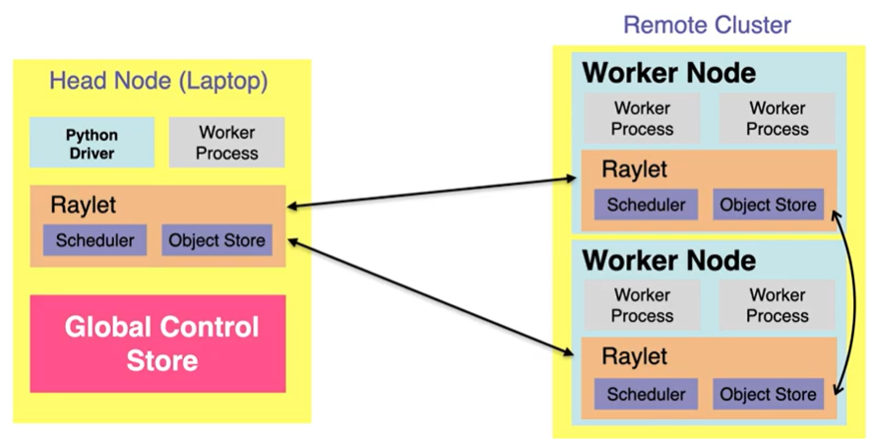

**Ray Layer Cake**

**Ray Core** (tasks & actors APi): interface between the cluster or where the machine are running

It Contains a Scheduler & Object Store & a Ray autoscaler

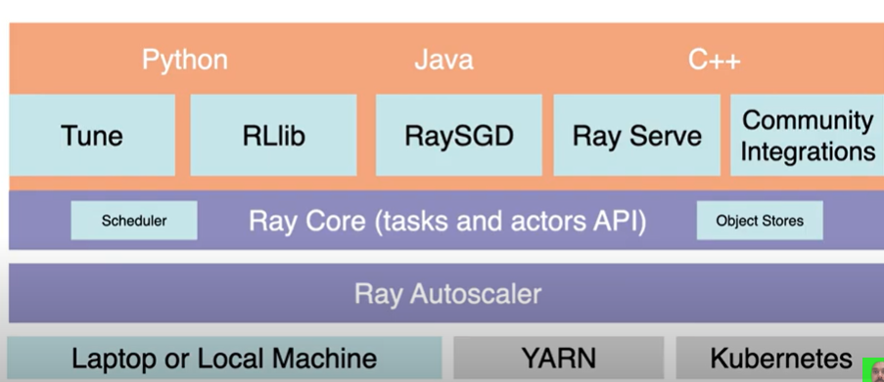

## Remote Functions in Python with Ray

**Start Ray Process:** call ray.init(ignore_reinit_error= True, logging_level = logging.ERROR)

**Ability to run function remotely:** add @ray.remote before the function



When we execute the function, I will execute it remotely on the distributed Ray cluster

Works asynchronously

**Look at Ray Dashboard**

## Stateful Distributed Computing in Python with Ray Actors

Ray Tasks: Remote functions (stateless functions)

Ray Actors: Remote Classes / Objects - Maintain internal state

**Example of Ray Actors:**

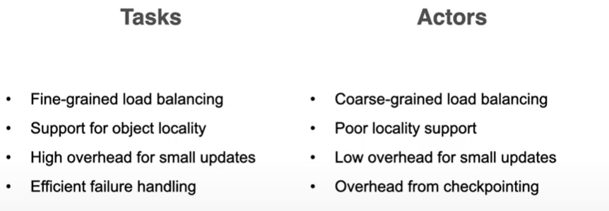

## Autoscaling Machine Learning APIs in Python with Ray

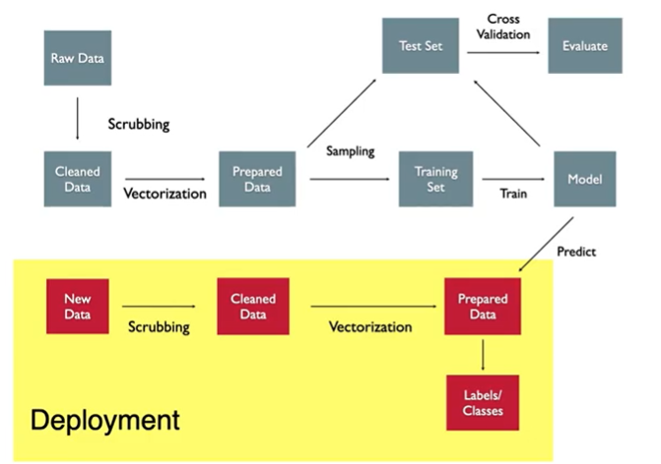

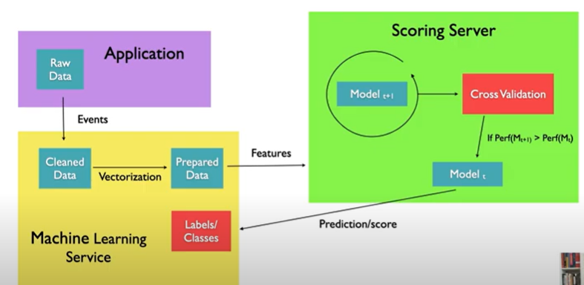

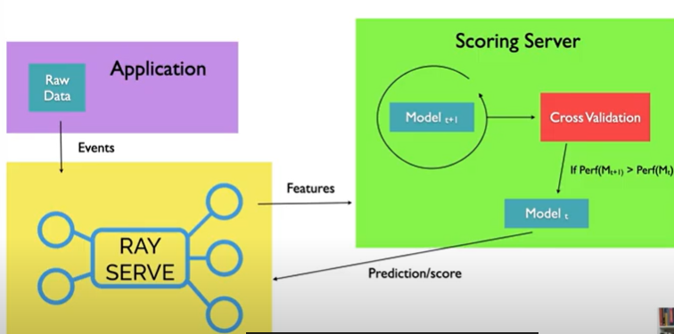

Need a ray cluster running

* Ray.init()

Start server framework

Create a backend & endpoint

It will register method, name ‘model’ & put the function predict

Then we create an endpoint



Requests to a localhost

**Example with machine learning API**



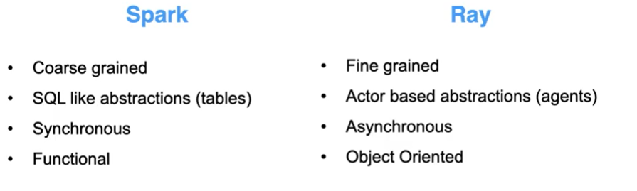

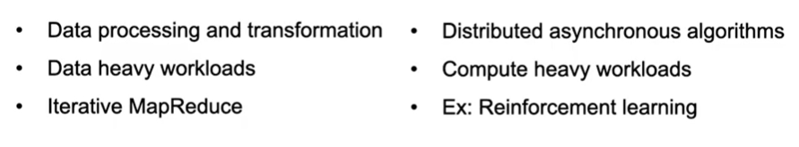

Use Locust for testing

## Documentation

**Introduction to Distributed Computing with the Ray Framework:** <https://www.youtube.com/watch?v=cEF3ok1mSo0&list=PLmetp36hFxewLPhAK6xrg0g_o-3aPJ_kA&index=2&ab_channel=clearspandex>

**Remote functions in Python with Ray:**

<https://www.youtube.com/watch?v=jua2dFrHSUk&list=PLmetp36hFxewLPhAK6xrg0g_o-3aPJ_kA&index=2&ab_channel=clearspandex>

**Github Repo – Scaling data science:**

<https://github.com/clearspandex/scaling-data-science>

**Stateful Distributed Computing in Python with Ray Actors:**

<https://www.youtube.com/watch?v=a051mbC9zqw&list=PLmetp36hFxewLPhAK6xrg0g_o-3aPJ_kA&index=3&ab_channel=clearspandex>

**Autoscaling Machine Learning APIs in Python with Ray:**

https://www.youtube.com/watch?v=Xa_94PuUYQI&list=PLmetp36hFxewLPhAK6xrg0g_o-3aPJ_kA&index=4&ab_channel=clearspandex

**Locust:**

[**https://locust.io**](https://locust.io)